**APPENDIX**

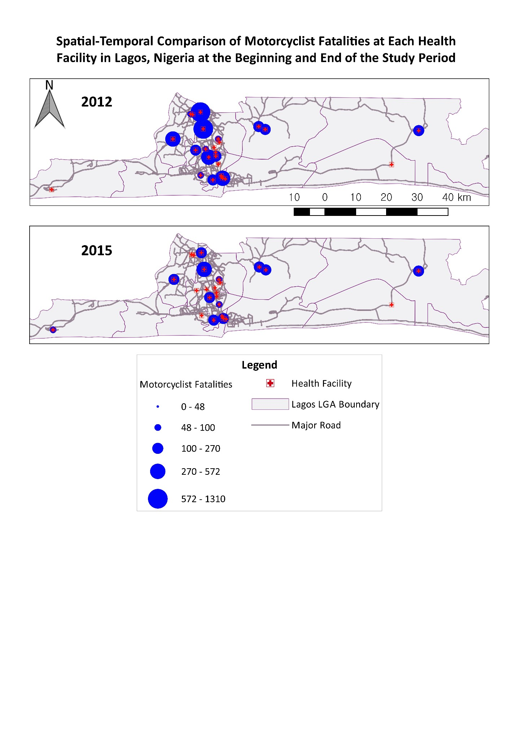

**Figure A1: Spatial-temporal illustration of motorcyclist fatalities in each of the 26 secondary- and tertiary-level health facilities in Lagos, including local government area boundaries and major roads, in 2012 and 2015. The red crosses represent the location of each facility, while the blue circles represent the number of fatalities recorded at a given facility and increase in size with the mortality burden.**

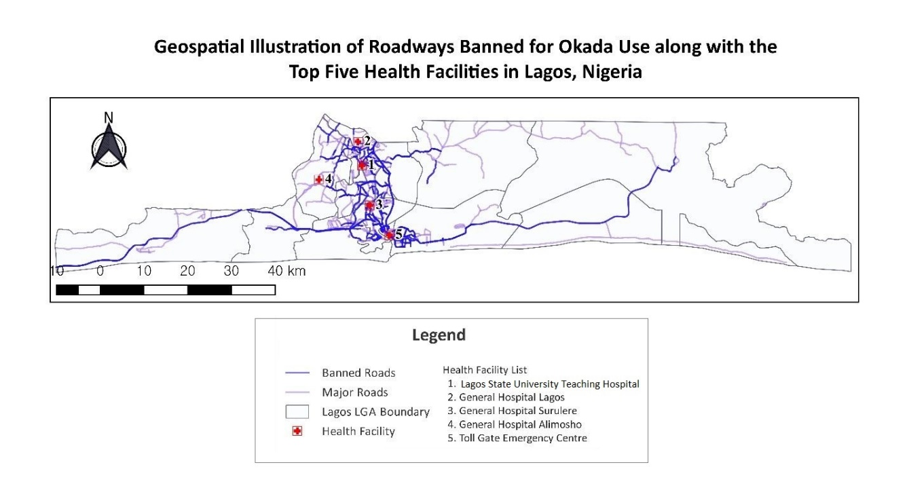

**Figure A2: Geospatial representation of the roadways that motorcycles are banned from as a result of the Lagos State Road Traffic Law of 2012, along with the top five health facilities with the greatest burden of motorcyclist fatalities. The blue lines represent the banned roads and the purple lines represent the major roads, while the red crosses represent the location of each health facility.**

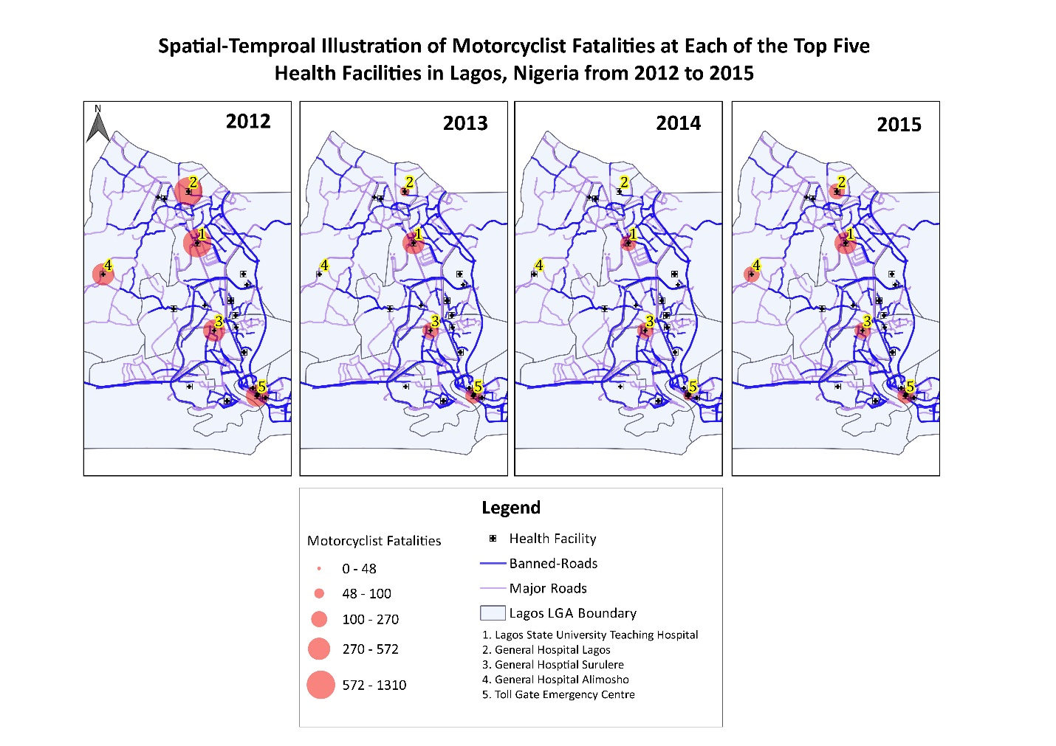

**Figure A3: Spatial-temporal illustration of the changes in the recorded motorcyclist fatality burden at each of the top five health facilities (Lagos State University Teaching Hospital, General Hospital Lagos, General Hospital Surulere, General Hospital Alimosho, and Toll Gate Emergency Centre) from 2012 to 2015. The black crosses represent the location of each facility, the red circles represent the number of fatalities recorded at a given facility and increase in size with the mortality burden, and the blue lines represent the banned roadways.**